Vectors and Linear motion Physics Year 11

Name: _______________________ Date: _______________ Mark _________/ 55

*For full marks, clearly show your working.*

Question 1 ( 2 marks)

A super-bouncy ball hits a wall with a velocity of 7.0 m s–1 east andrebounds with a velocity of 6.0 m s–1 west. Determinethe change in velocity of the ball.

Question 2 (1 mark)

Which of the options below contains only vector quantities?

A displacement, velocity, acceleration, force

B displacement, speed, acceleration, weight

C distance travelled, velocity, acceleration, force

D displacement, velocity, acceleration, mass

____________________

Question 3 ( 1 mark)

Which vector diagram shows the correct addition of vectors 15 N west and 5 N east, and the correct resultant vector *R*?

**A** **B**

***R***

***R***

**C** **D**

***R***

***R***

_______________________

**Question 4 (7 marks)**

The graph below shows the displacement of a farmer on a motorcycle, riding to and fro along a boundary of his property while counting livestock.

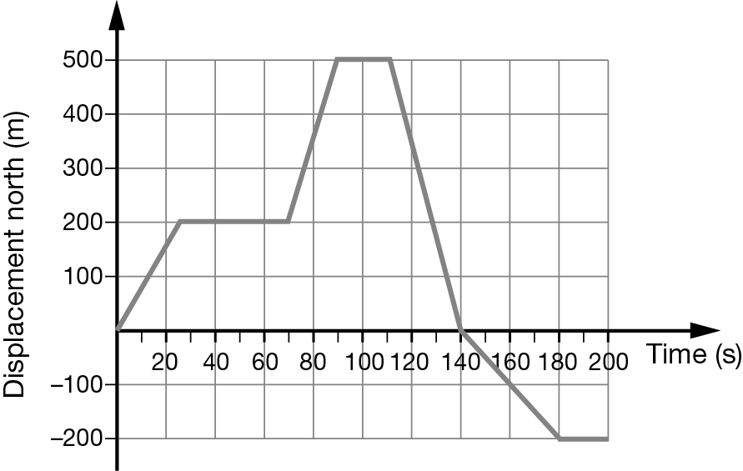

1. How far did the farmer travel during the first minute? ( 1 mk)

_________________

b) ( 2 mks)

Which of the following describes the motion of the farmer at t = 120 s? Explain or show your reasoning

A stationary

B heading forwards with a speed of 17 m s–1

C decelerating

D returning back with a speed of 17 m s–1

_______________

_______________________________________________________________________

________________________________________________________________________

c) Determine the total distance travelled by the farmer over the entire period? ( 2 mks)

d) Determine the average velocity of the farmer during the last 60 s of his journey? ( 2 mks)

Question 5 (12 marks)

A car reaches a speed of 72 km h–1, from rest, in a time interval of 5.0 s.

a What was the average acceleration of the car in metres per second? (2 marks)

b The car then maintains this speed for 15 s. How far is it from its starting position at the end of the 15 s? (3 marks)

c The car now decelerates uniformly at a rate of 4.0 m s–2, until it comes to a stop. On the axes provided, draw the velocity–time graph for the car’s entire journey. (3 marks)

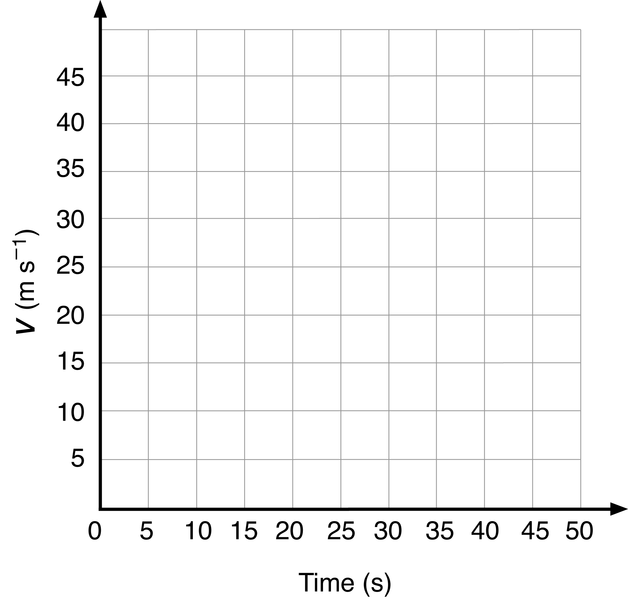

**d.** Using the graph determine the total displacement. *(No marks if graph not used)* (3 marks)

e. Calculate the average velocity of the car during its entire journey. (1 mark)

Question 6 ( 6 marks)

A car travels 1.00 km east, 2.00 km south, 3.00 km west and 4.00 km north.

1. Draw a vector diagram, drawing the relative lengths correctly ( 3 marks)
2. Determine the resultant displacement of the car. (3 marks)

Question 7 ( 4 marks)

A radio-controlled toy car starts next to a grass tree on the school oval. It travels 20 m north and then travels 15 m east.

a Determine the total distance travelled by the car? (1 mark)

b Determine the car’s displacement from the grass tree. (3 marks)

Question 8 ( 6 marks)

A cyclist rides 1.50 km east along a straight path at 27.0 km h−1 before she suddenly notices a ‘path closed’ sign ahead, causing her to stop.

a What is the cyclist’s initial speed in m s−1? (1 marks)

**b** If she takes 0.590 s to react to the sign, what distance does she travel before braking? (2 marks)

**c** Once she pulls on her brakes, the cyclist decelerates at 2.50 m s−2. How far does she travel while coming to rest? (2 marks)

**d** What total distance does the cyclist travel from the time she first notices the ‘path closed’ sign to when she comes to a stop? (1 mark)

Question 9 ( 9 marks)

A stone is thrown upwards at 30.0 m s–1 from the top of a cliff and lands in the sea 40.0 m below. Ignore the effects of air resistance.

a Calculate the speed of the stone when it hits the sea below. (3 marks)

b Determine the total time the stone was moving in the air. (3 marks)

c How far above the sea did the stone reach? (3 marks)

**Question 10 (7 marks)**

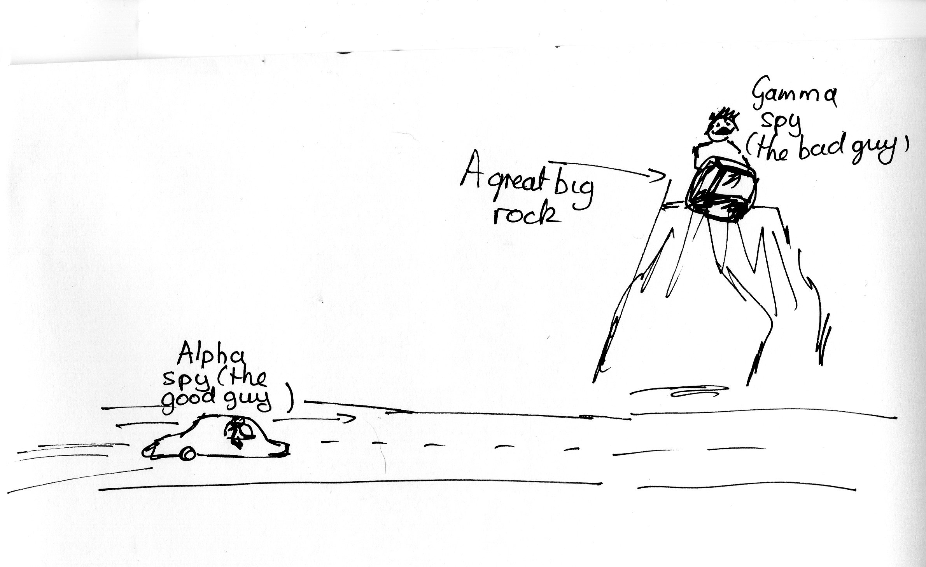

In a cartoon (shown above), the **alpha spy** (the good guy) is trying to get past the **gamma spy** (the bad guy).

The gamma spy is on a ledge 80.0 m directly above a road when he sees the alpha spy in a car travelling towards him at a constant velocity of 12.4 ms-1. The gamma spy drops a large rock off the ledge when the alpha spy is 50.0 m from the point on the road directly below the ledge**.**

**Does the gamma spy drop the rock on the alpha spy?**

Show all working to justify your answer